SHELL SCRIPTING

1) Print 1 to 100

var=1
echo "$var"
var=$((var+=1))
echo "$var"
var=$((var+=1))
echo "$var"
var=$((var+=1))
echo "$var"

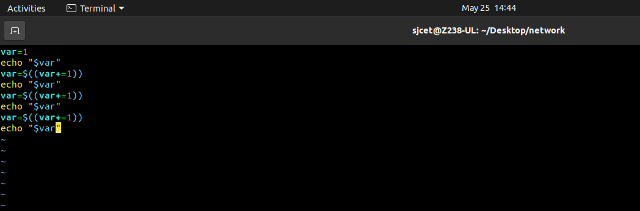

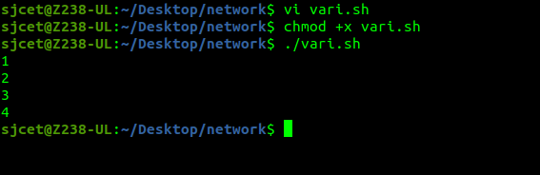

2) Shell Program to check whether the number is odd or even in the list

read -p "Enter a number: " number
if [ $((number%2)) -eq 0 ]
then
echo "Number is even."
else
echo "Number is odd."
fi

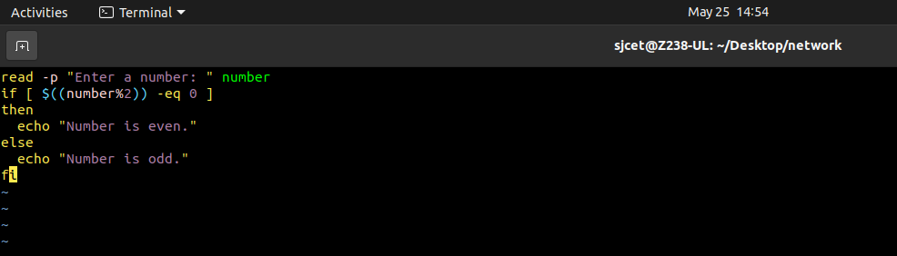

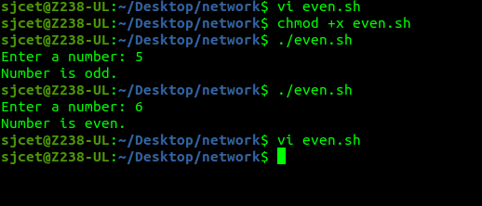

3) shell script for factorial of a number

echo "Enter a number"
read num

fact=1

while [ $num -gt 1 ]
do
fact=$((fact * num))
num=$((num - 1))
done

echo $fact

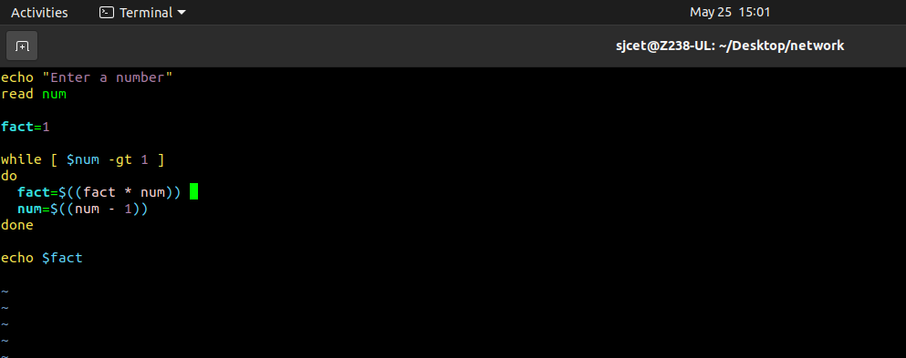

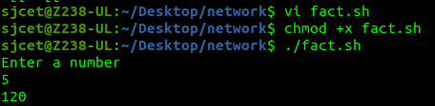

4) Sum of all digits

echo "Enter a number"
read num

sum=0

while [ $num -gt 0 ]
do
mod=$((num % 10))
sum=$((sum + mod))
num=$((num / 10))
done

echo $sum

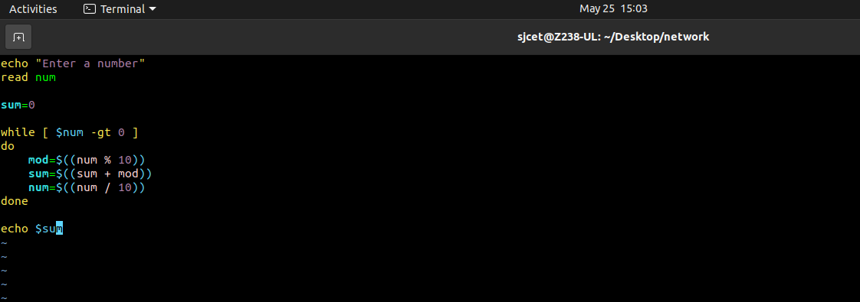

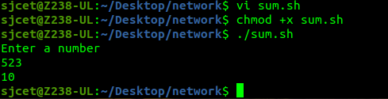

5)Print numbers 1 to 100 using while loop

i=1
while [ $i -le 100 ]
do
echo $i
i=$(($i+1))
done

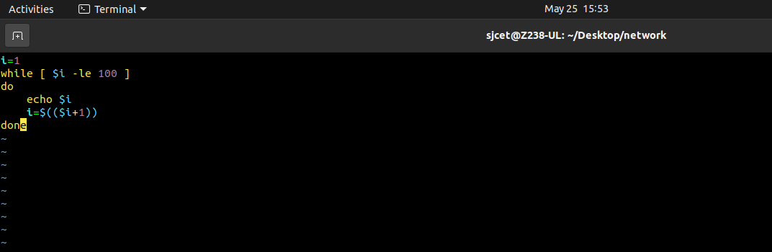

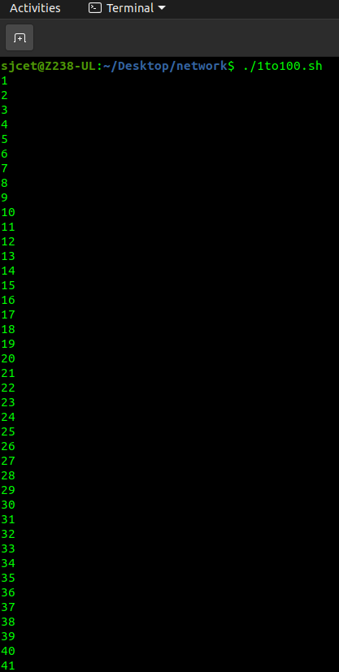

6)Largest of n numbers

echo "Enter Size(N)"
read N

i=1
max=0

echo "Enter Numbers"
while [ $i -le $N ]
do
read num
if [ $i -eq 1 ]
then
max=$num
else
if [ $num -gt $max ]
then
max=$num
fi
fi
i=$((i + 1))
done

echo $max

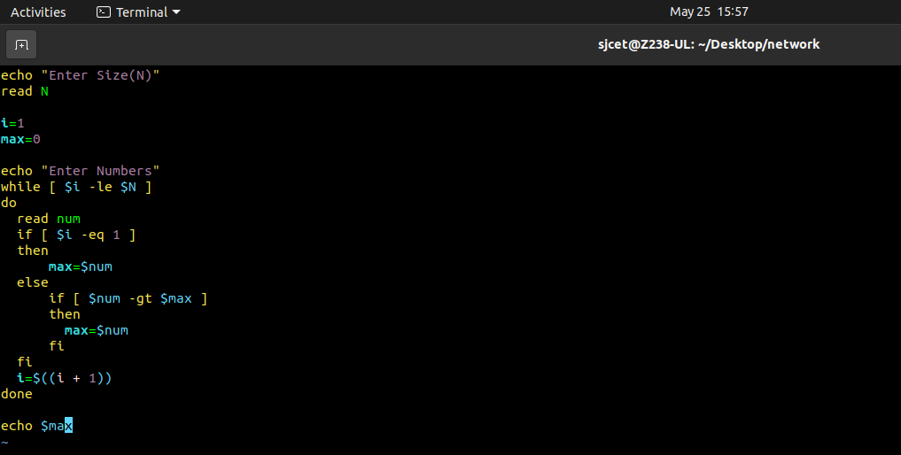

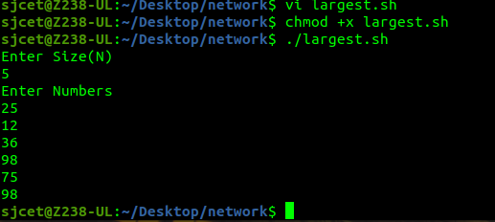

7) Shell script for finding greatest of three numbers

echo "Enter Num1"
read num1
echo "Enter Num2"
read num2
echo "Enter Num3"
read num3

if [ $num1 -gt $num2 ] && [ $num1 -gt $num3 ]
then
echo $num1
elif [ $num2 -gt $num1 ] && [ $num2 -gt $num3 ]
then
echo $num2
else
echo $num3
fi
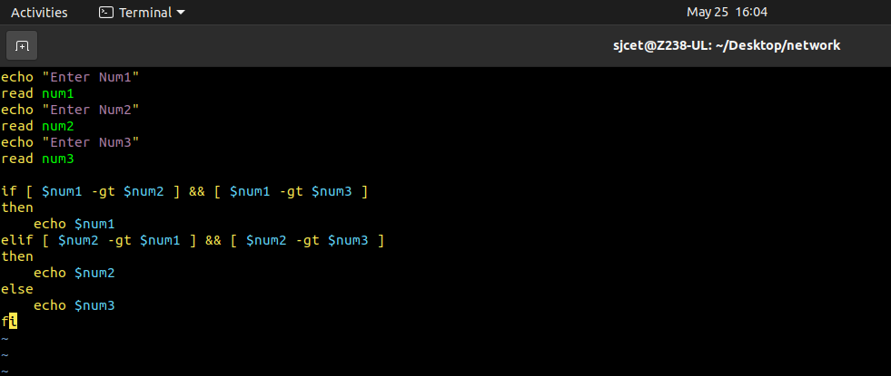

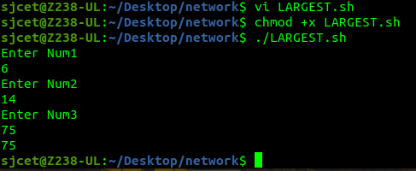

8) Multiplication of two numbers using expr in shell script

num1=10
num2=20
ans=`expr $num1 \* $num2`
echo $ans

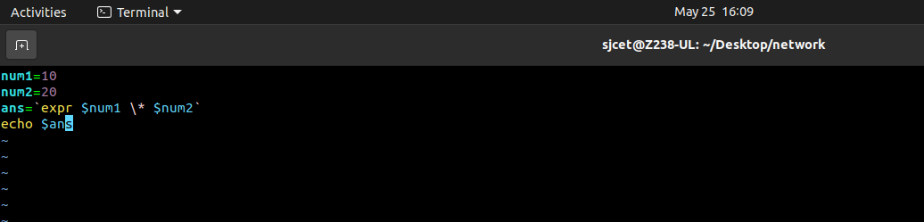

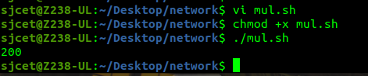

9)Add array elements - Shell Script

arr=(10 20 30 40 50)

sum=0

for i in ${arr[@]}
do
sum=`expr $sum + $i`
done

echo $sum
~

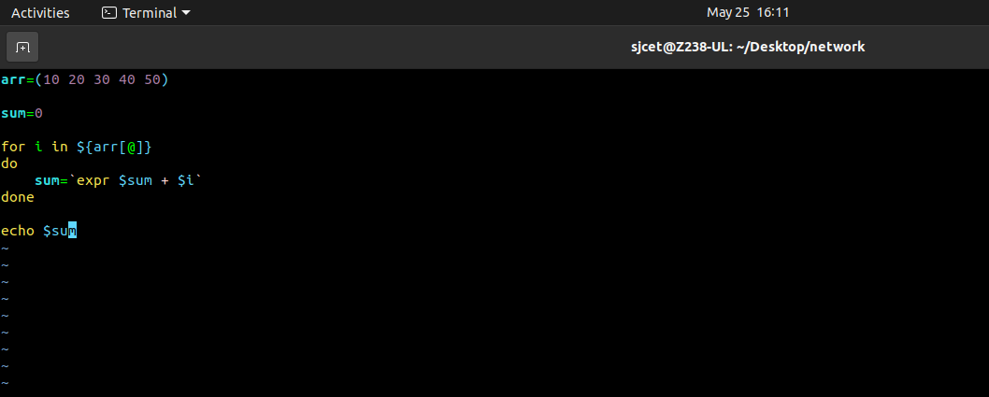
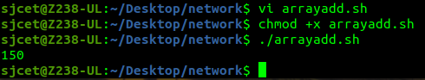

10) Shell script to compare two strings

read -p "Enter two strings: " str1 str2

if [ $str1 == $str2 ]
then
echo "Equal"
else
echo "Un Equal"
fi

